CUSTOMER JOURNEY MAP

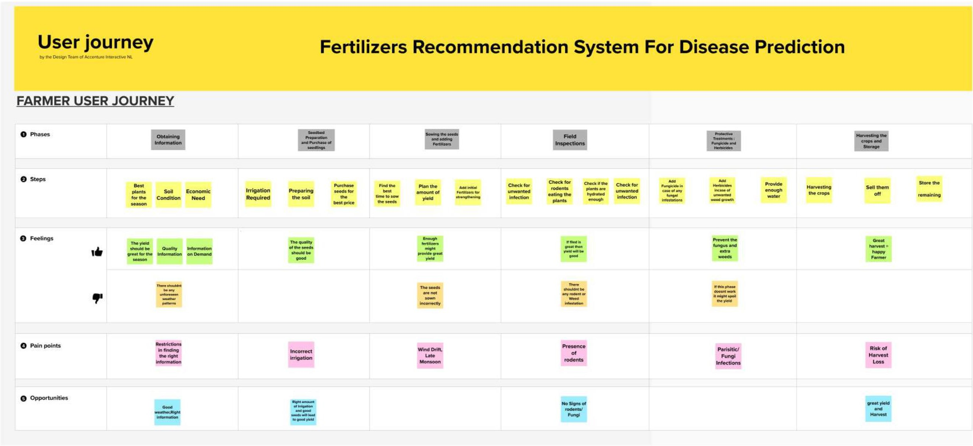**TEAM ID:** PNT2022TMID54187